Ques 2 : Create a Kubernetes cluster using kubeadm

SOLN :

Difference Between Minikube and Kubeadm

Minikube is a lightweight Kubernetes tool designed for local development and testing on a single machine. In contrast, kubeadm is used to set up multi-node, production-like Kubernetes clusters with fine-grained control over components. While Minikube is ideal for beginners and prototyping, kubeadm simulates real infrastructure, making it better suited for DevOps and cloud environments.

FOR THIS WE NEED MINIMUM 2 MACHINE OR NODES

1 MASTER NODE
2 WORKER NODE

SO FOR THIS WE WILL USE VM WITH THE HELP OF AZURE VM INTERFACE TO GET THROUGH IT

MASTER NODE :

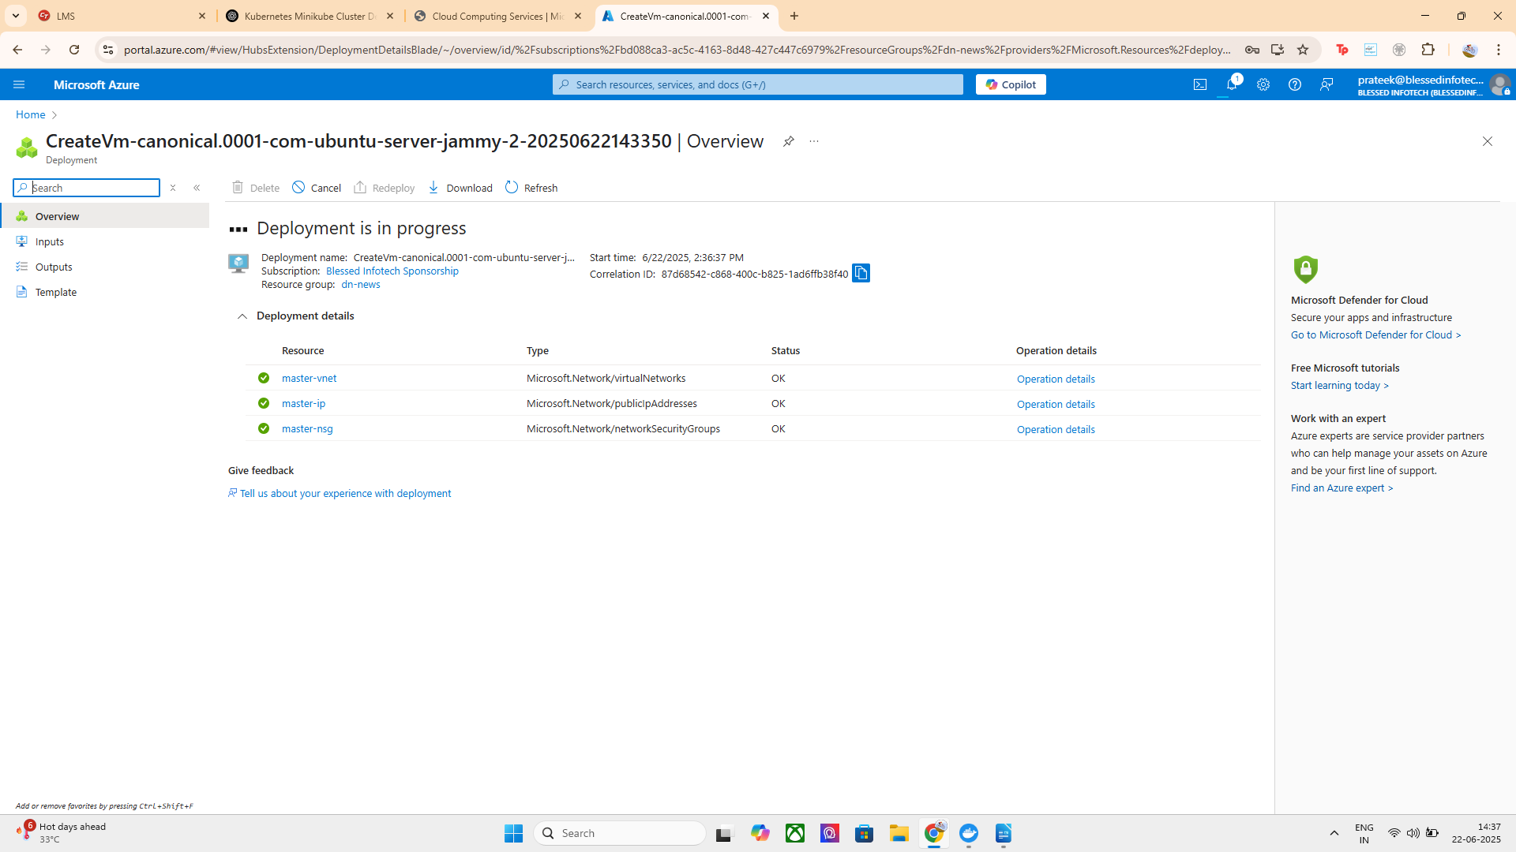

WORKER NODE :

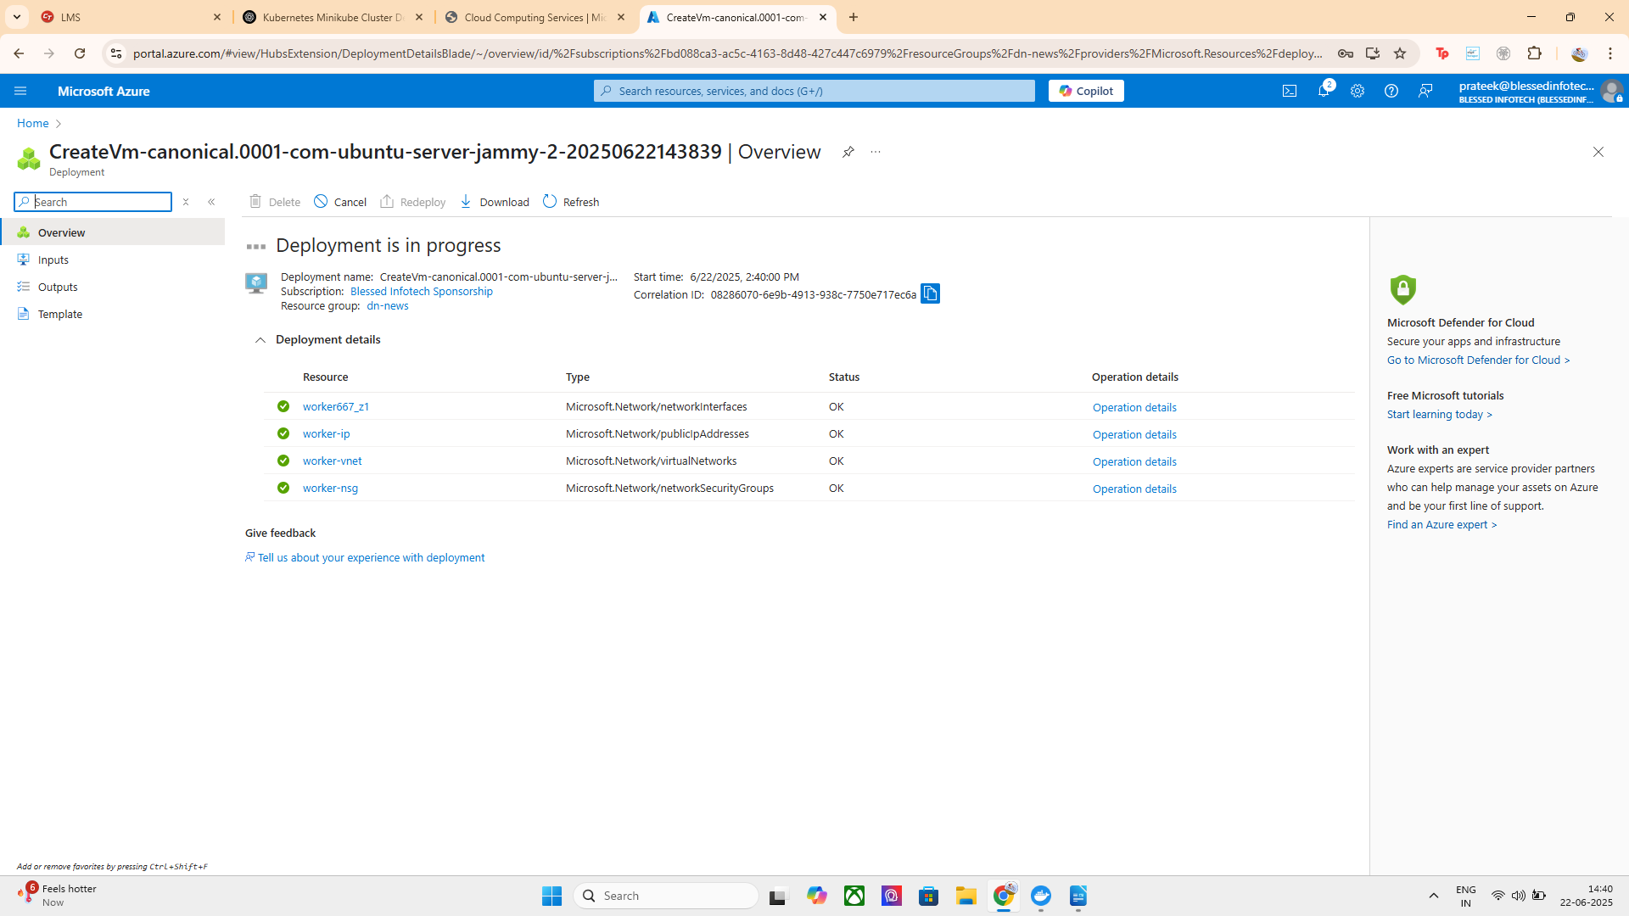

Now SSH Into VMs

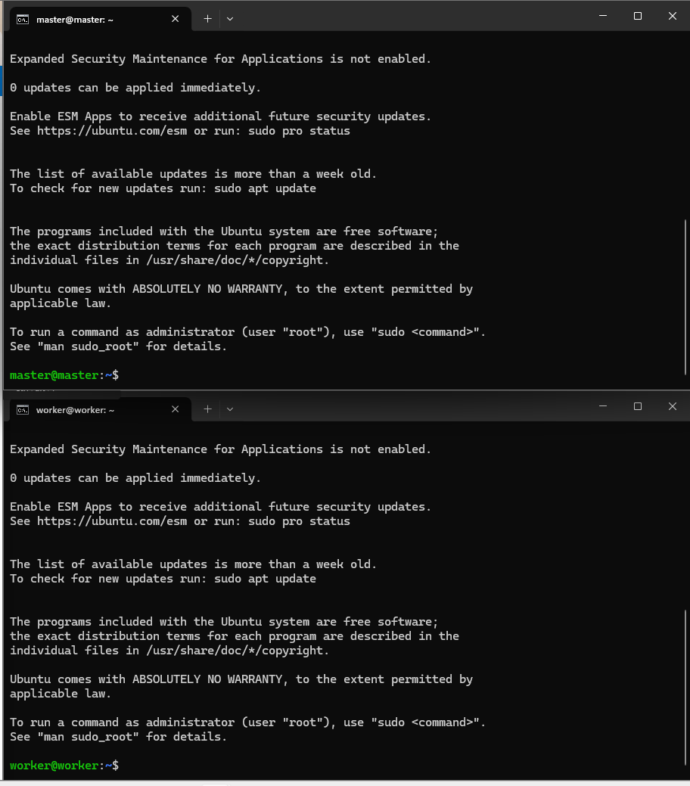

Install Kubernetes & Container Runtime (On Both VMs)

commands used :

# Disable swap
sudo swapoff -a
sudo sed -i '/ swap / s/^/#/' /etc/fstab

# Install container runtime (containerd)
sudo apt update
sudo apt install -y containerd

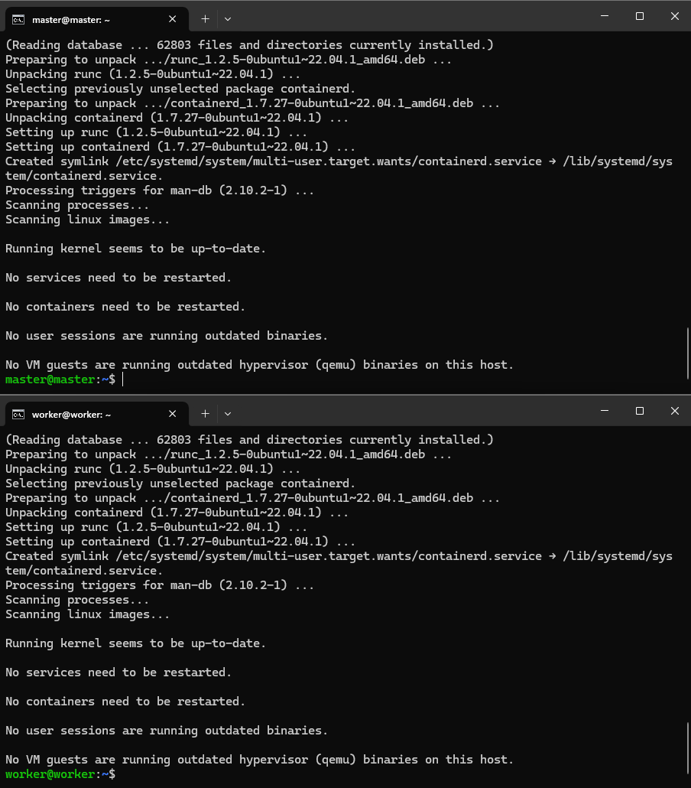

sudo mkdir -p /etc/containerd
containerd config default | sudo tee /etc/containerd/config.toml
sudo systemctl restart containerd
sudo systemctl enable containerd

# Install kubeadm, kubelet, kubectl
sudo apt update && sudo apt install -y apt-transport-https curl
curl -s https://packages.cloud.google.com/apt/doc/apt-key.gpg | sudo apt-key add -
echo "deb https://apt.kubernetes.io/ kubernetes-xenial main" \
| sudo tee /etc/apt/sources.list.d/kubernetes.list

sudo apt update
sudo apt install -y kubelet kubeadm kubectl
sudo apt-mark hold kubelet kubeadm kubectl

This is the common error i faced on installation

How to switch to the new repo on Ubuntu 22.04 (Jammy)
The commands below install the current stable stream (v1.30).
If you need a different minor version, replace v1.30 everywhere with e.g. v1.29.

# 1) Clean up any old entry that points to apt.kubernetes.io
sudo rm -f /etc/apt/sources.list.d/kubernetes.list

# 2) Create keyring directory (needed on Ubuntu 22.04)
sudo mkdir -p /etc/apt/keyrings

# 3) Add the new signing key
curl -fsSL https://pkgs.k8s.io/core:/stable:/v1.30/deb/Release.key \
| sudo gpg --dearmor -o /etc/apt/keyrings/kubernetes-apt-keyring.gpg

# 4) Add the new APT repository
echo "deb [signed-by=/etc/apt/keyrings/kubernetes-apt-keyring.gpg] \
https://pkgs.k8s.io/core:/stable:/v1.30/deb/ /" \
| sudo tee /etc/apt/sources.list.d/kubernetes.list

# 5) Update indexes and install the tools
sudo apt update
sudo apt install -y kubelet kubeadm kubectl
sudo apt-mark hold kubelet kubeadm kubectl

KUBEADM SUCCESSFULLY INSTALLED ON BOTH THE MASTER AND WORKER VMS

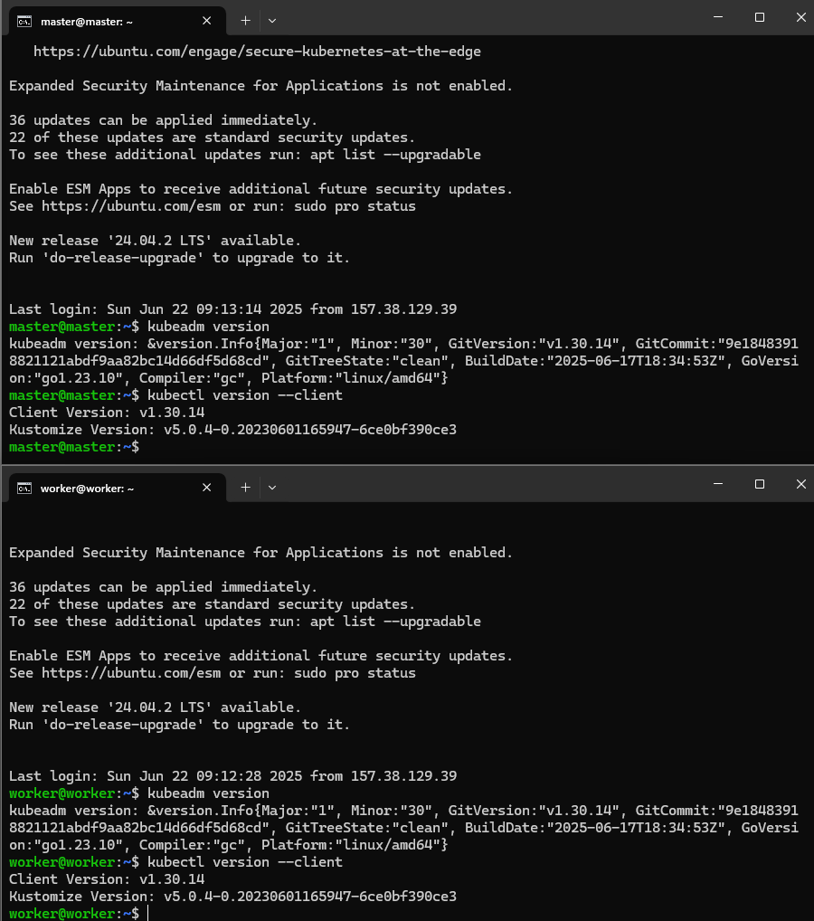

NOW WE HAVE TO INITIALIZE THE Kubernetes (Master Node Only)

Enable IP Forwarding
Run the following command to enable IP forwarding temporarily:
sudo sysctl -w net.ipv4.ip_forward=1
echo "net.ipv4.ip_forward=1" | sudo tee -a /etc/sysctl.conf
sudo sysctl -p
COMMAND USED : sudo kubeadm init –pod-network-cidr=192.168.0.0/16

MASTER READY TO JOIN

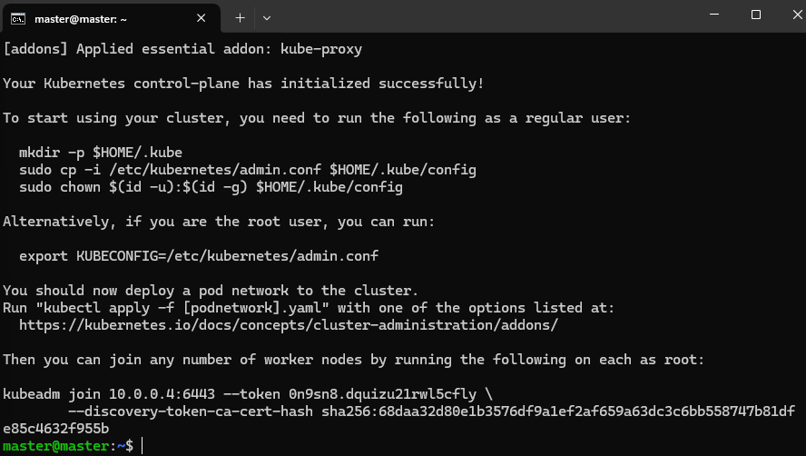
After success, copy the output that contains the kubeadm join command.
Then:
mkdir -p $HOME/.kube
sudo cp /etc/kubernetes/admin.conf $HOME/.kube/config

Install Pod Network (Calico) ON MASTER NODE

kubectl apply -f https://docs.projectcalico.org/manifests/calico.yaml
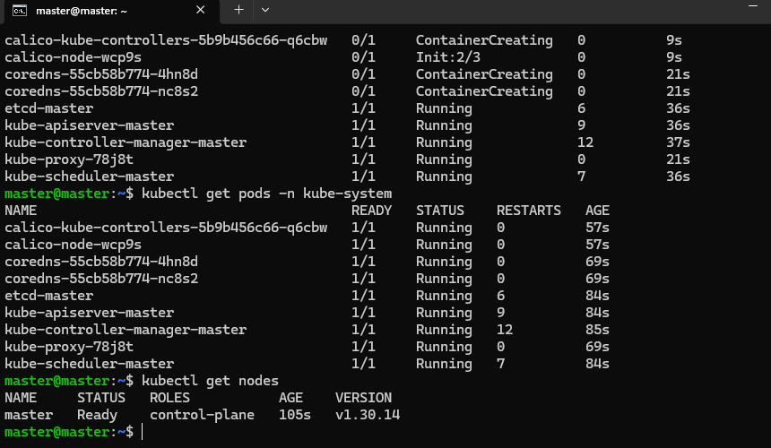
NOW LETS JOIN THE WORKER NODE :

COMMAND USED : sudo kubeadm join <master-ip>:6443 --token <token> --discovery-token-ca-cert-hash sha256:<hash>

Fix on Worker Node
Run these on the worker node:
# Enable temporarily
sudo sysctl -w net.ipv4.ip_forward=1

# Make it persistent
echo "net.ipv4.ip_forward=1" | sudo tee -a /etc/sysctl.conf
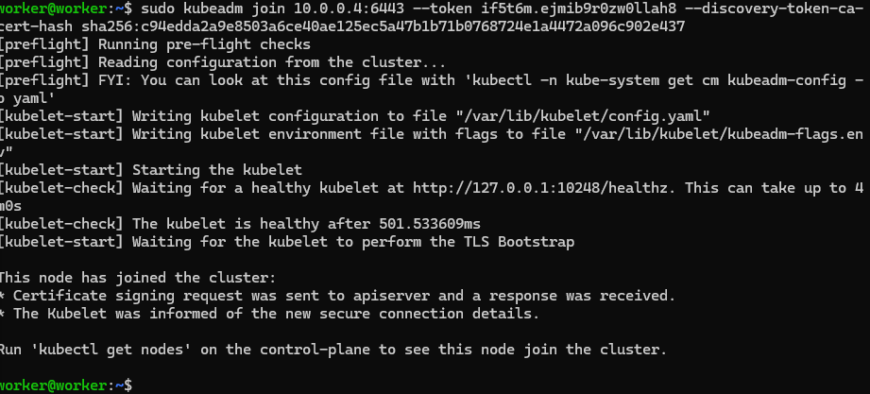
sudo sysctl -p

Verify Nodes (Back on Master)
On master node its connected successfully :
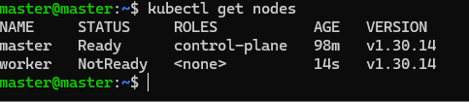

FACED CALIO ISSUSE REINSTALLED IT FROM BEGINNING SO NOW :
BOTH READY
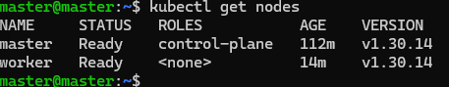

NOW , Let's Deploy a Sample App (Nginx)
Step 1: Create the Deployment
COMMAND USED : kubectl create deployment nginx –image=nginx

Step 2: Expose the Deployment via a NodePort service
kubectl expose deployment nginx --port=80 --type=NodePort

Step 3: Get the Service Details

kubectl get svc nginx
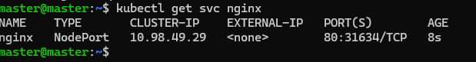
NOW ALLOW THE PORT INTO VMS INBOUND RULE

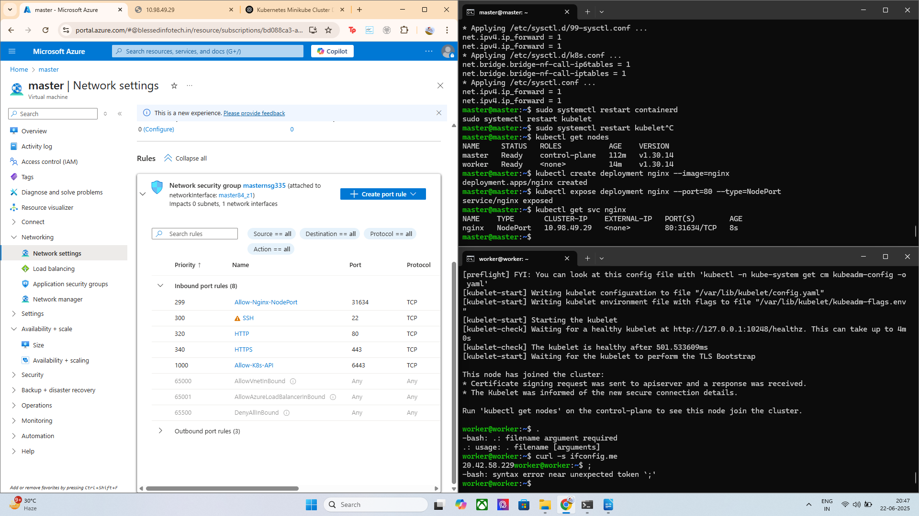

Access the App
Open your browser and visit:

http://<ANY_NODE_PUBLIC_IP>:<NodePort>
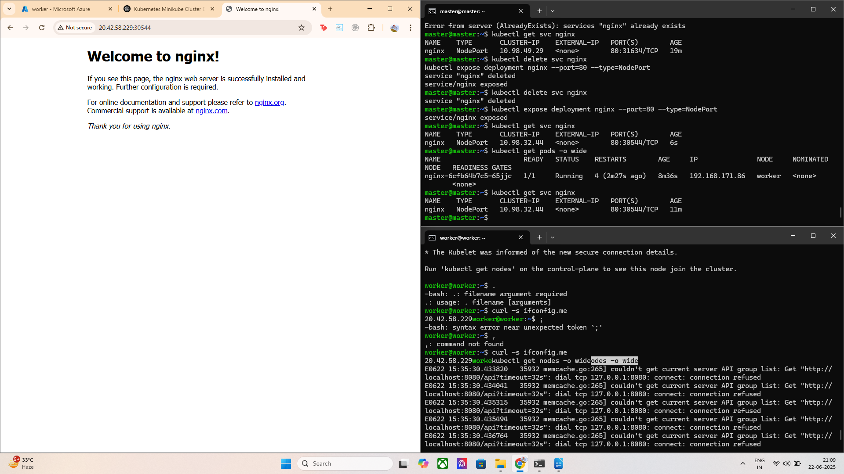
most important command : kubectl get pods -o wide
So basically i was concerned why my master not running the application this is what i found so i thought i should share :

Kubernetes master nodes manage the cluster's control plane and are tainted to avoid running application pods.
This ensures high availability and performance of cluster operations.
Only worker nodes are used to run user workloads by default.
To run pods on the master, taints must be removed or tolerated explicitly.

Lets deploy some custom application image on the same using kubeadm
I have used my portfolio website image:
https://hub.docker.com/r/prateek2004/my-frontend
steps :
1 > Create a deployment (replace your-dockerhub-username/your-image:tag with your actual image):
command used : kubectl create deployment my-app --image=your-dockerhub-username/your-image:tag

2> Expose the deployment as a service:
Command used : kubectl expose deployment my-app --type=NodePort –port=80
3> Get the NodePort to access the app:
command used : kubectl get svc my-app

Access using:
http://<your-node-ip>:<node-port>

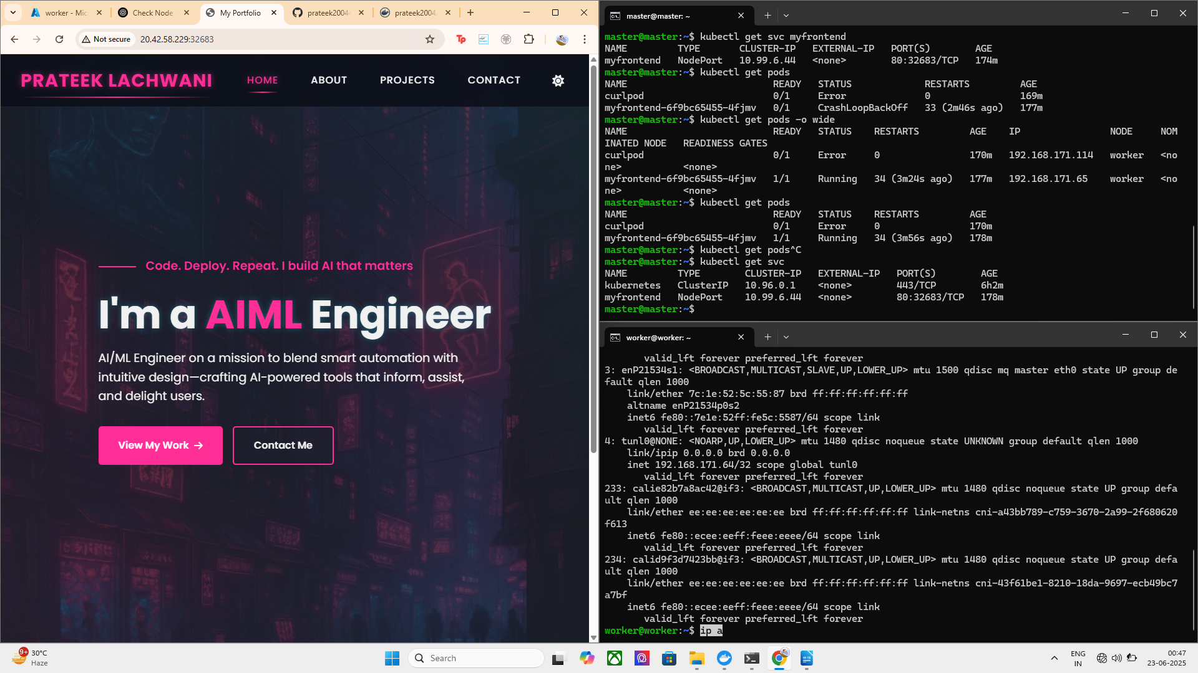
ALL THE CLUSTERS AND NODES ARE SUCCESSFULLY WORKING AND THE DEPLOYMENT IS SUCCESSFULLY MADE

